[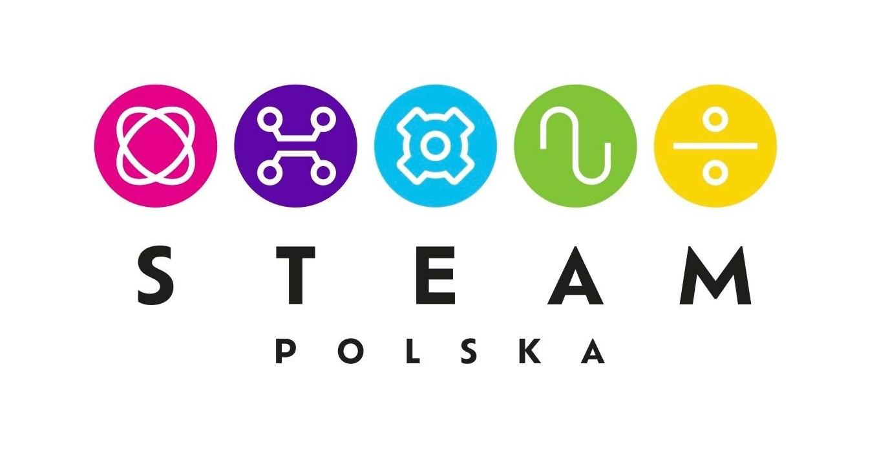](https://www.steampolska.org/)

February 2024  *Press release*

**STEAM Education**

**STEAM is a modern educational model that aims at the comprehensive development of students and their competencies of the future.**

**STEAM is a combination of five key disciplines: Science, Technology, Engineering Arts, Mathematics.**

**STEAM is based on project-based learning, in which students, under the guidance of an educator, seamlessly move between the five disciplines, working in teams and using their unique talents and skills.**

**STEAM uses proven tools of the digital and mobile revolution as well as classic analog tools, allowing students to combine learning with artistic expression and craftsmanship, unleashing imagination, creativity and unconventional thinking.**

The STEAM educational model has been developed in the world for almost 20 years. It was initiated by the Rhode Island School of Design in Providence, which began to promote the inclusion of art and design in the popular STEM educational model (science, technology, engineering, mathematics) in order to create STEAM - a more comprehensive and creative model that better prepares future generations to function in the innovative economy of the 21st century.

According to the Rhode Island School of Design, "*the goal is to support innovation that results from the combination of the scientist/technologist's mind with the artist/designer's concept."* Incorporating art into the original STEM concept takes STEM to the next level - it allows students to combine learning with artistic expression, unleashing imagination, creativity and unconventional thinking, thus using the full potential of the student.

STEAM puts the student in the role of a researcher, explorer, designer and executor who uses science, technology, engineering, art and mathematics to create their own solutions, projects and innovations. In the STEAM model, students work creatively, collaborate, take risks, experiment, solve problems, have the opportunity to make mistakes and learn from them.

STEAM can be implemented at all educational levels, starting from preschool and the skills acquired during STEAM classes will be used by students throughout their lives, regardless of their chosen profession.

Most children starting primary school now will work in professions that do not yet exist. Moreover, all research on market development trends indicates that they will change their profession several times during their lives. Most new professions will be created in the area of new technologies, and it seems that digital skills will remain one of the most important components of modern education. At the same time, researchers emphasize that adaptive skills to rapid changes will be equally important for students - the ability to learn quickly, search for information, think critically, solve problems creatively and unconventionally, communicate easily and cooperate. STEAM teaches how to learn, how to ask questions, experiment, learn from mistakes - it is therefore an excellent educational model that equips students with a package of future competencies, in which the most important are social, digital and cognitive competencies.

STEAM classes use a variety of tools, selected to suit the purpose of the project. These can be digital tools: computers, tablets, robots, microcontrollers, measuring interfaces, multimedia boards, 3D printers and pens or VR goggles, as well as analog tools, such as art supplies, tools for DIY, audio-video equipment, blocks, fabrics, toys and recycled items.

In STEAM, classes are conducted in the form of short- and long-term projects that are embedded in reality, and students solve real problems, often identified by themselves. The teacher is a tutor, moderator and guide, encouraging students to ask questions, reflect, experiment and discover, i.e. to use methods of independent knowledge acquisition and competence development.

"*Let's imagine a school where children come not to take, for example, five hours of classes in different subjects, but a school where they come to face a real social challenge, the solution of which will change some part of the world, and at the same time will allow children to gain knowledge from different disciplines and a range of social competences. This way of thinking about education is the quintessence of the education of the future, this way of thinking about education is the quintessence of STEAM"* - says prof. Marlena Plebańska, a precursor of the STEAM educational model, inspirer, expert and strategist of solutions in the field of distance learning, new media and technologies, President of the STEAM Polska Foundation.

**Contact for the Press:**

Marta Czapińska

Fundacja STEAM Polska

Tel.: +48 513 662 364

marta.czapinska@steampolska.org