[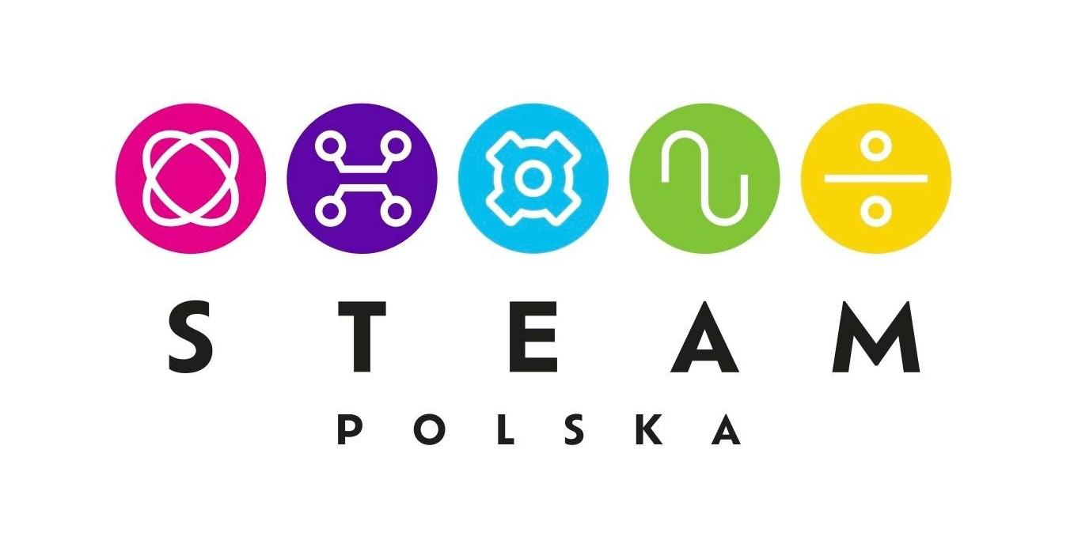](https://www.steampolska.org/)

**About STEAM Polska Foundation**

STEAM Polska Foundation supports children, youth and adults, as well as teachers and educators in acquiring the skills necessary to function in society and economy 5.0.

Economy 5.0 assumes sustainable economic and social development and is based on knowledge, data and innovation.  
  
The Foundation helps shape the competences of the future in a comprehensive way, in particular: advanced digital, social and cognitive skills.

The aim of the Foundation is to disseminate design education consolidating five key disciplines: natural sciences, technology, engineering, art and mathematics using proven tools of the digital and mobile revolution, as well as the latest technological trends in the field of robotics, the Internet of Things, artificial intelligence, and augmented and virtual reality. .

The Foundation, in cooperation with Technology Partners - producers and distributors of STEAM technologies - trains teachers both stationary and online as part of the STEAM Polska Academy. The training allows teachers to optimally use tools purchased by schools under the Polish government's Future Laboratories program and to create and implement STEAM lesson scenarios in line with educational goals and the core curriculum.

STEAM Polska Foundation is the only institution in Poland authorised to award STEAM EDUKATOR certificates as part of the European Odznaka+ certification program. These certificates are digitally secured in the Open Badges standard and awarded as part of the Integrated Qualifications System applicable throughout the European Union.

An educational institution that trains an appropriate number of teachers and successfully implements the STEAM model into the educational process receives a STEAM Preschool or STEAM School certificate.

The founder and President of the STEAM Polska Foundation is Marlena Plebańska, Professor of Knowledge Management, graduate of the Warsaw University of Technology, North East Wales Institute of Higher Education, Warsaw School of Economics. For twenty years, she has been an inspirator, expert and strategist of solutions in the field of distance learning, new media and technology. She implements innovative teaching methods in dozens of Polish schools, enterprises and non-governmental organisations. She authored over a hundred scientific publications and several dozen popular science publications. She is co-author of the books "STEAM lessons", "STEAM school" and "STEAM preschool". In 2022, she was honoured with the title of "Polish woman of the 21st century for promoting the STEAM method".

Press contact:

Marta Czapińska

STEAM Polska Foundation

Tel.: 513 662 364

marta.czapinska@steampolska.org